**Internet programming laboratory**

**Cse-326**

**K19gr group-2**

**Final report**



INDIAN ELECTRICITY Website

**SUBMITTED BY:-**

* **ZUBAIR AHMAD B38(11908946)**
* **JAPNEEK KOUR RAINA B39(11903872)**
* **MANHAR BHARDWAJ B40(11908995)**

**SUBMITTED TO:-**

**Mr. Ishan Kumar**

**CONTRIBUTION OF GROUP MEMBER**

**MANHAR BHARDWAJ(11908995):-**

Written code for the website development and prepared the website.

**Zubair Ahmad (11908946):-**

Wrote final report and by gathering information from internet.

**JAPNEEK KOUR RAINA(11908972):-**

Gathered information from various coding websites to write in the final report and written synopsis.

**Screenshots**

**HOMEPAGE**

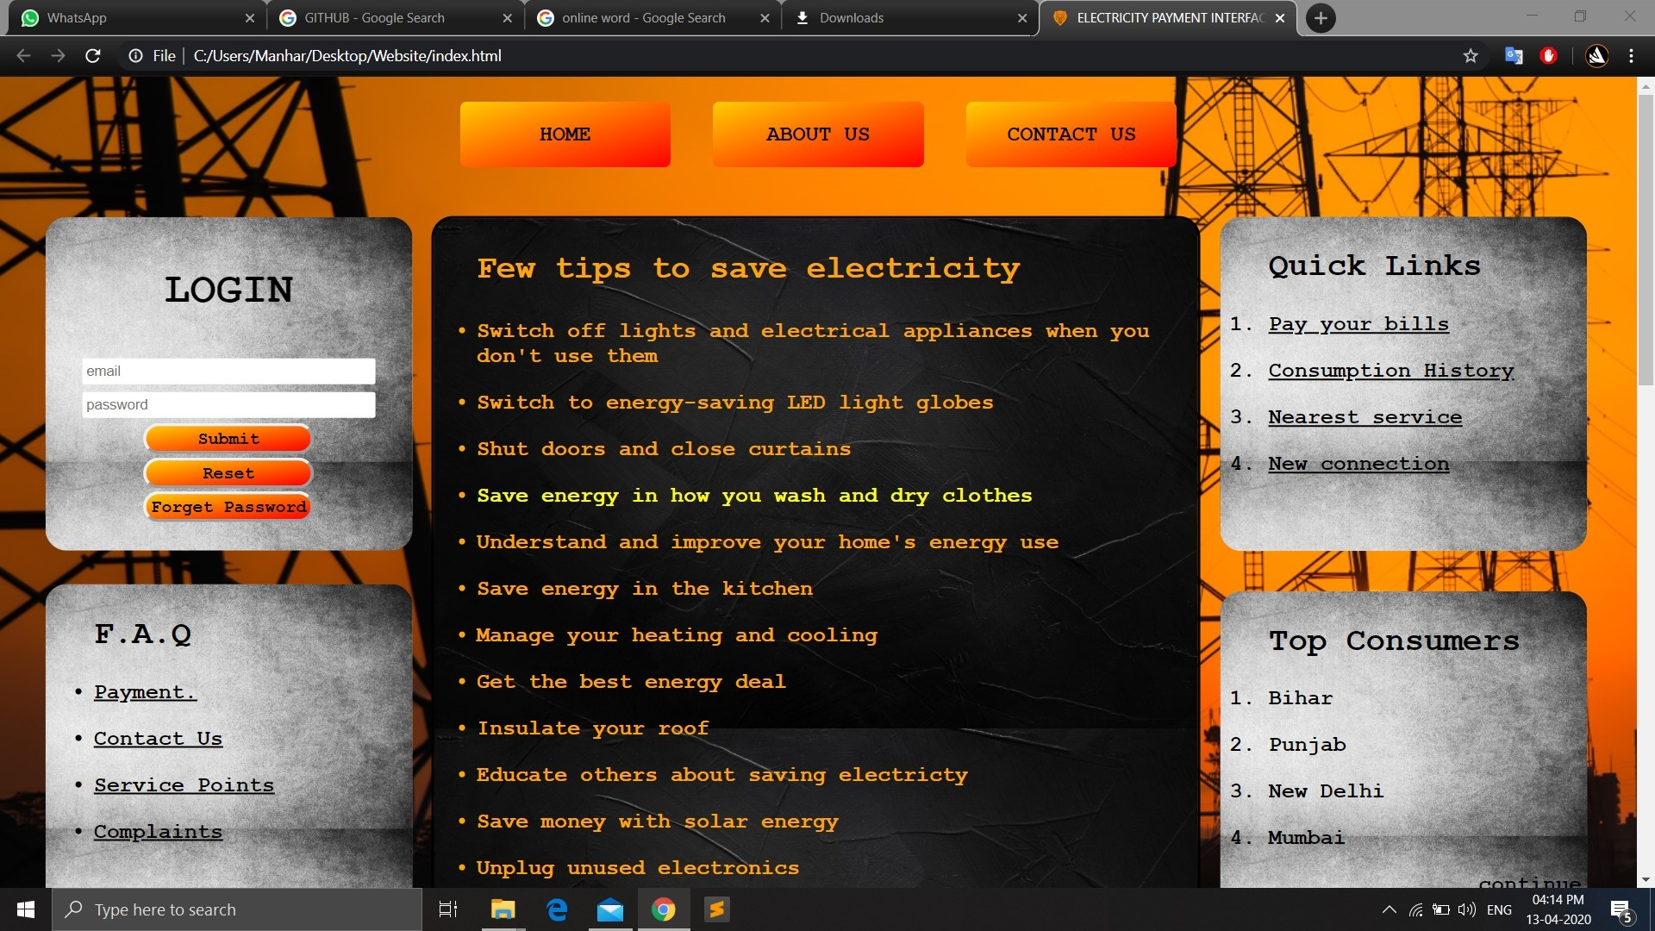

**PAYMENT INTERFACE**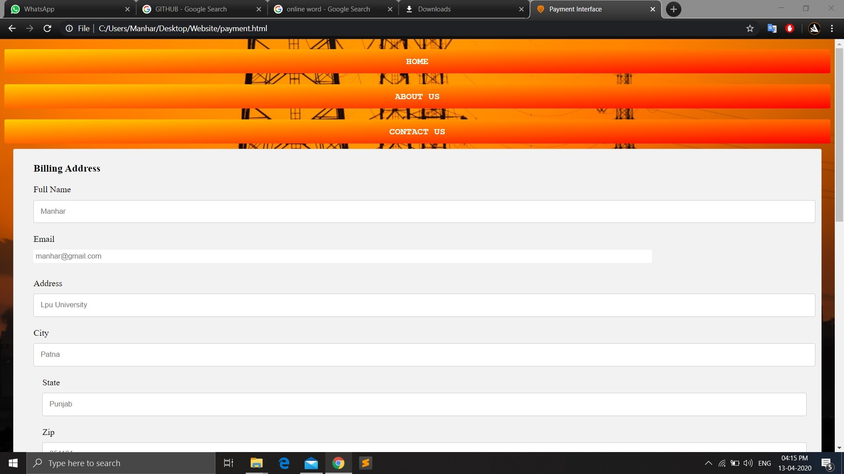

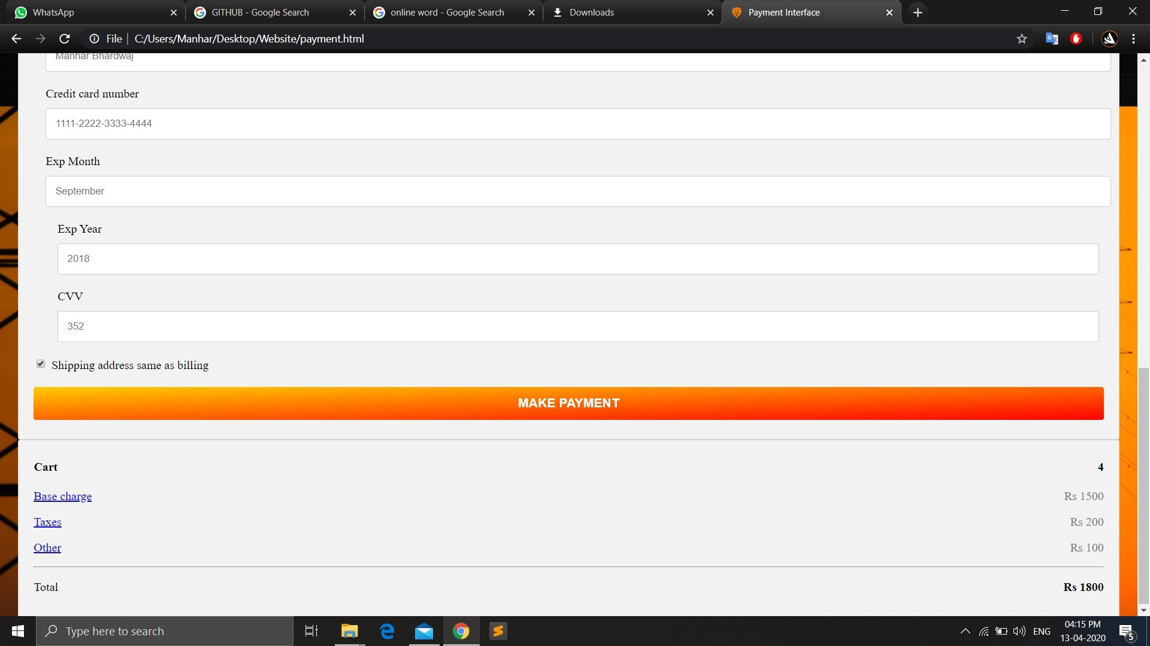

**ABOUT US**

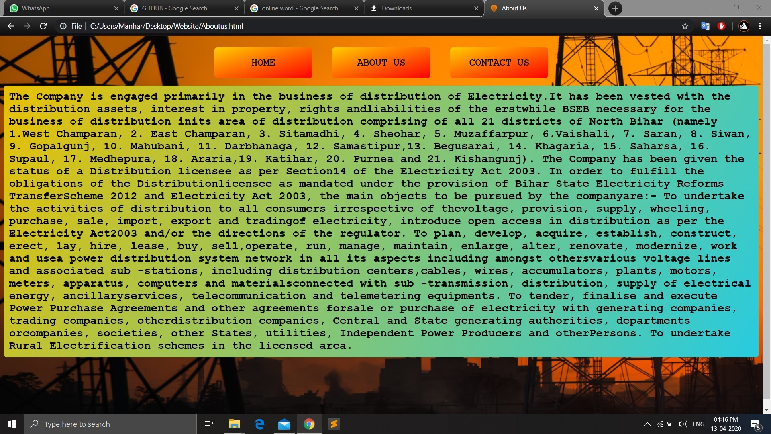

**CONTACT US**

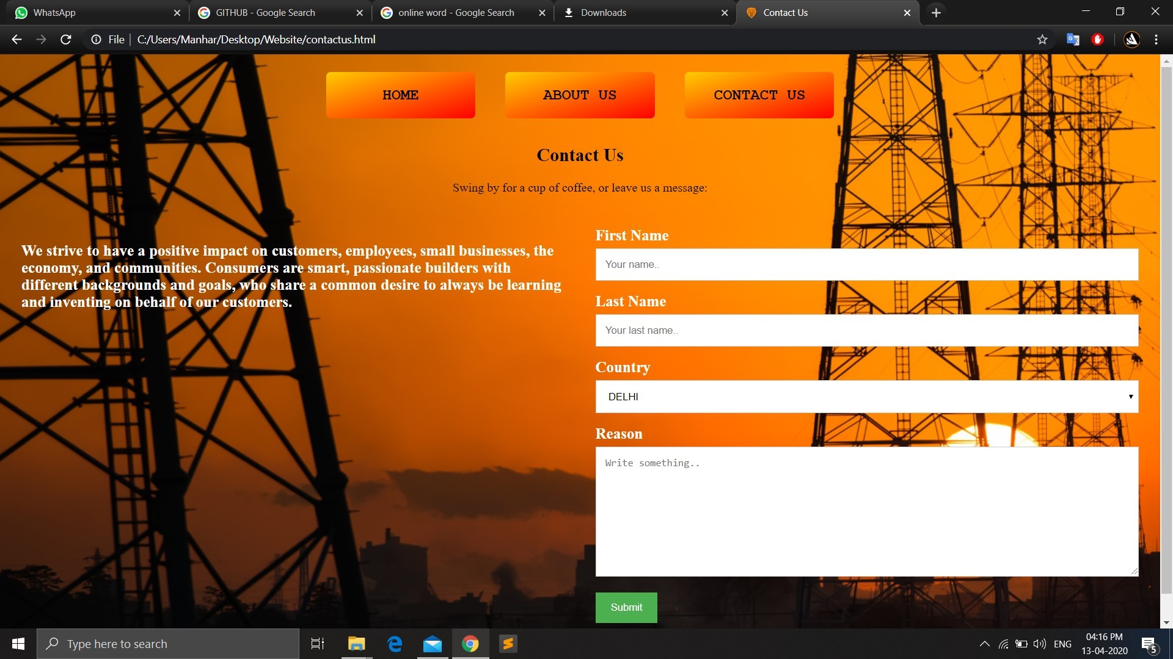

**INTRODUCTION**

**Hypertext Markup Language (HTML)** is the

standard markup language for documents designed to be displayed in a web browser. It can be assisted by technologies such as Cascading Style Sheets (CSS)and scripting languages such as JavaScript. HTML elements are the building blocks of HTML pages. With HTML constructs ,  images and other objects such as interactive forms may be embedded into the rendered page. HTML provides a means to create structured documents by denoting structural semantics for text such as headings, paragraphs, lists, links, quotes and other items. HTML can embed programs written in a scripting language such as JavaScript, which affects the behavior and content of web pages. Inclusion of CSS defines the look and layout of content. The World Wide Web Consortium (W3C), former maintainer of the HTML and current maintainer of the CSS standards, has encouraged the use of CSS over explicit presentational HTML since 1997.

Web browsers receive HTML documents from a web server or from local storage and  render the documents into multimedia web pages. HTML describes the structure of a web page semantically and originally included cues for the appearance of the document.

**CSS (Cascading Style Sheets)** is used to style and lay out web pages — for example, to alter the font, color, size, and spacing of your content, split it into multiple columns, or add animations and other decorative features. This module provides a gentle beginning to your path towards CSS mastery with the basics of how it works, what the syntax looks like, and how you can start using it to add styling to HTML.

**JavaScript** is a dynamic computer programming language. It is lightweight and most commonly used as a part of web pages, whose implementations allow client-side script to interact with the user and make dynamic pages. It is an interpreted programming language with object-oriented capabilities.

JavaScript was first known as Live Script, but Netscape changed its name to JavaScript, possibly because of the excitement being generated by Java. JavaScript made its first appearance in Netscape 2.0 in 1995 with the name Live Script. The general purpose core of the language has been embedded in Netscape , Internet Exporer, and other web browsers.

**TAGS USED**

* **HTML ELEMENTS:-**

An HTML element usually consists of a start tag and an end tag with the content

Inserted in between <tagname> content

Goes here . </tagname>

# HTML Styles – CSS:

**CSS**  stands for **C**ascading **S**tyle **S**heets.CSS describes **how HTML elements are to be displayed on screen, paper, or in other media**.CSS **saves a lot of work**. It can control the layout of multiple web pages all at once.CSS can be added to HTML elements in 3 ways:

* **Inline** :-**B**y using the style attribute in HTML elements.
* **Internal** - By using a <style> element in the <head> section.
* **External** - **B**y using an external CSS file.

## The class Attribute:

## To define a style for special types of elements, add a class attribute to the element, then define a style for the elements with the specific class.

# HTML Links:

HTML links are hyperlinks. Hyperlinks are defined with the HTML <a> tag. The href attribute specifies the destination address of the link.The **link text** is the visible part .

# HTML Images:

In HTML, images are defined with the <img> tag.The <img> tag is empty, it contains attributes only, and does not have a closing tag.The src attribute specifies the URL (web address) of the image. You can use the style attribute to specify the width and height of an image. Alternatively, you can use the width and height attributes.

# HTML Lists:

An unordered list starts with the [<ul>](https://www.w3schools.com/tags/tag_ul.asp) tag. Each list item starts with the [<li>](https://www.w3schools.com/tags/tag_li.asp) tag.The list items will be marked with bullets (small black circles) by default. An ordered list starts with the [<ol>](https://www.w3schools.com/tags/tag_ol.asp) tag. Each list item starts with the [<li>](https://www.w3schools.com/tags/tag_li.asp) tag.The list items will be marked with numbers by default.

# HTML Buttons:

The <button> tag defines a clickable button.Inside a <button> element you can put content, like text or images. This is the difference between this element and buttons created with the <input> element.

# HTML textarea:

The <textarea> tag defines a multi-line text input control.A text area can hold an unlimited number of characters, and the text renders in a fixed-width font.The size of a text area can be specified by the cols and rows attributes, or even better; through CSS' height and width properties.